Proceedings ITU-IAHS International Conference on the Kocaeli Earthquake 17 August 1999: A Scientific Assessment and Recommendations for Re-Building, M Karaca and D. N. Ural, editors, Istanbul Technical University 1999, ISBN 975-561-166-5, pp. 193-204.
International Journal for Housing Science and Its Applications, ISSN 0146-6518, Special Issue: Kocaeli Eathquake 1999, Oktay Ural, Editor-In-Chief, Vol. 24, No. 1, 2000, pp. 85-96.
Earthquake Damage, Site Response, and Building Response in Avcilar, West of Istanbul, Turkey
Edward Cranswick¹, Oguz Ozel², Mark Meremonte¹, Mustafa Erdik², Erdal Safak¹, Charles Mueller¹, Dee Overturf¹, Arthur Frankel¹
16 November 1996
1 U.S. Geological Survey, MS 966, Box 25046, Federal Center, Denver, CO 80225, USA; cranswick@usgs.gov
2 Earthquake Engineering Department, Kandilli Observatory & Earthquake Research Institute, Bogaziçi University, 81220 Çengelköy/ Istanbul, Turkey; ozeoguz@boun.edu.tr
Introduction
To evaluate the seismic hazard of Istanbul, Turkey, it is necessary to know the site response of the city and its environs and to estimate how the resulting ground motions might interact with the built environment. Approximately one thousand people were killed by the collapse of buildings in Istanbul during the 17 August 1999 Kocaeli Earthquake whose epicenter is roughly 90 km east of the city. Most of the fatalities and damage occurred in the suburb of Avcilar that is 20 km further west of the epicenter than the city proper. Shortly after the first damage reports arrived at the National Earthquake Information Center (NEIC), the striking resemblance between ground motion and damage patterns in the Avcilar district and Istanbul in 1999 and the Marina district and San Francisco during the Loma Prieta Earthquake in 1989 was noted (Wesson, personal communication, 1999; see Hough et al., 1990, for discussion of a building/site-response investigation using Loma Prieta aftershocks). Avcilar was also a site of earthquake damage in 1894 (Holzer, personal communication, 1999). The mechanism responsible for this localization of damage is both intriguing and important.
Commencing within five days of the earthquake, a team from the U.S. Geological Survey (USGS) in cooperation with colleagues from the Earthquake Engineering Department of the Kandilli Observatory (KOERI) began an aftershock investigation (see also Mueller et al., in review). The main objectives were to study site effects by comparing aftershock ground motions recorded at sites inside and outside the damage areas, and to study propagation of the seismic wavefield recorded on small arrays. The USGS team brought 16 portable digital seismographs and supporting equipment to Turkey. Each unit is capable of recording many hours of digitized, three-component ground acceleration and/or velocity time series; the data can be transferred to portable computers and analyzed in the field. Data from the initial deployment, lasting from August 24 to September 2, is discussed here. (Most of the instruments were still in Turkey and had been redeployed several times at the time of this writing in late October 1999).
Figure 1A is a map showing instrument locations and epicenters of aftershocks recorded by at least one station during the initial deployment. From west to east, the map shows instrument deployments in Avcilar, West Istanbul, Dilovasi, Korfez, and Adapazari. Figure 1B shows the three-component records produced at these sites by a magnitude-5.2 (M5.2) aftershock (August 31 08:10) that has almost the same epicenter as the mainshock (see Figure 1A).
Based on the instrument characteristics of their equipment, the USGS/KOERI team divided into two groups: one investigated strong ground motions in the epicentral area to the east, and the other investigated the relatively weak ground motions of Avcilar in the west. The portable digital seismographs, RefTek PASSCALs*, that we (Meremonte et al., 1999) had available were equipped with only weak-motion sensors, Marks Products 2-Hz L-22 geophones, that could not record strong ground motions on-scale. Therefore, these instruments could not be effectively deployed in the epicentral area during the early part of the aftershock sequence. However, at sites like Avcilar and Istanbul, far from the epicentral area where the aftershocks produced weak motions, we could use these instruments to document both the site response and the building response, and correlate these observations with the geologic structure and the building damage.
Site Response and Damage in Avcilar and West Istanbul
To investigate the pattern of damage produced by the mainshock, i.e., little damage to the Istanbul proper but greater damage to its western suburbs, we deployed seven portable seismographs at sites in Avcilar and West Istanbul to record aftershocks. These included a small-aperture (~200 m), tripartite array in the damaged neighborhood of Avcilar (AB1, AC1, AD1), and an instrument (AT1) co-sited with a digital strong-motion accelerograph ~1 km west of town that recorded the mainshock (KOERI Station ATS; 0.24% g). Avcilar and vicinity is underlain by as much as 200 m of poorly lithified calcareous sand, marl, and oolitic limestone (Upper Miocene) and unconsolidated Pliocene sand and gravel (Kapp et al., 1969). For the purpose of this study, we will refer to this strata as "soft rock". To acquire a representative sample of ground motion from the soft rock strata, we deployed two other stations: at Yesilkoy (YS1) where there was some damage and near the Istanbul airport (AR1) where there was no damage. We also deployed a station at a reference rock site (HL1; underlain by Devonian limestones and greywackes) that we selected as being representative of strata beneath the undamaged areas of Istanbul proper. Figure 2A shows the locations of these stations with respect to the geotechnical properties of the underlying strata. The radial components of ground velocity of the M5.2 aftershock recorded at these sites, low-pass filtered at 0.25 Hz (4.0-s period), are shown in the W-E pseudo-recordsection of Figure 2B. Station AT1 was equipped with a Guralp broadband seismometer, and its records have been high-pass filtered with a 2-pole Butterworth at 2 Hz to give them the same response characteristics as those of the other stations equipped with L-22 geophones. Station AT1 and the three stations in the damaged neighborhood, particularly AB1, exhibit large amplitude and very prominent Raleigh waves that begin approximately 8 s after the corresponding S-waves. Figure 3 is a photograph of the remains of an apartment building that stood – before the earthquake – less than 30 m from Station AB1.
Figure 4 displays the pseudo-recordsections of three other large aftershocks (M4.1, 4.6, 4.8) recorded by the stations shown in Figure 2. In general, ground motions <0.25 Hz in the damaged area are 2-4 times greater than those of the less damaged and undamaged areas underlain by similar geology, i.e., Yesilkoy and the "soft-rock" site, and an order of magnitude greater than those at the rock site. The consistency of the ground motion amplification of the damaged sites relative to that of the undamaged sites over a range of epicentral distances that spans 200 km (50, 100, 207 km) suggests that regional focusing effects, such as those that produce SmS phases, do not contribute significantly to the amplitude differences. In the frequency band >1.0 Hz, the ground velocities of more than 50 aftershocks are consistently higher at Yesilkoy than at the other sites, and this may be due to a localized surficial layer of low-velocity unconsolidated sediments at Yesilkoy. Station AT1 regularly recorded ground motions that were smaller but comparable to those of Station AB1, and that station is colocated with a permanent station that recorded the largest peak accelerations in Istanbul during the mainshock. However, the mainshock caused little damage here, presumably because the plant consists of buildings and structures that are less fragile than the surrounding apartments.
Building Response
We evaluated the response characteristics of a building located within the area of the small-aperture array in the damaged neighborhood of Avcilar (Figure 5). Other than some minor cosmetic cracking of stucco, plaster and tiles, the building is apparently undamaged, even though at least four buildings adjacent or in close proximity to, i.e., within the damage array, collapsed during the earthquake. The building was instrumented with an L-22 geophone in the basement and another L-22 resting on the concrete ceiling above the 6th floor, below the tile roof . The signals from both sensors were recorded by one 6-channel RefTek PASSCAL 72-08 DAS in both trigger mode at 100/200 sps and continuous mode at 25 sps. Figure 6 displays both the basement and roof records (plotted on the same time and amplitude axes) of a M3.9 aftershock (October 11 02:47, near the M4.1 aftershock near Yalova; see Figure 1A). Note that the verticals have similar amplitudes but the amplitudes of the horizontal components in the roof are much larger than those in the basement, reflecting the amplification of ground motion produced by the building response.
Discussion and Conclusions
Assuming that there is no systematic difference in building design or construction practice between Avcilar and Istanbul, the question is: what difference in ground motion caused the difference in damage? Hence, what is the difference in site response between these two areas? Or more precisely, is there a correlation between site response and building response that makes buildings in Avcilar more susceptible to failure than those in Istanbul? To estimate this correlation, we calculated the NS and EW horizontal building responses and the radial and tangential horizontal site responses. The building responses are the ratios of the spectra of the horizontal roof records to the spectra of the corresponding basement records of the M3.9 aftershock (see Figure 6). The site responses are the ratios of the spectra of the horizontal Station AB1 records to the spectra of the corresponding Station HL1 (reference rock site) records of the M5.2 aftershock. All records are ~80-s long at 25 sps. Figure 7 is a log-frequency/log-amplitude plot of the two horizontal components of both of these spectral ratios, i.e., the building responses and the site responses. Both the NS and EW components of the building response exhibit the peaks between 2-3 Hz that would be expected of the fundamental mode of a 5-6 story building (assuming a period of ~0.1 s per floor), and these peaks have amplitudes – factors of roof/basement amplification – of 8-13. The radial component of site response peaks at 0.3–0.4 Hz with an amplitude – a factor of Avcilar/Istanbul amplification – of 13, and this corresponds to the timeseries amplitudes of Station AB1 relative to other stations as seen in Figure 2B and Figure 4. The tangential component peaks at about 2 Hz, i.e., at nearly the same frequency as the building response, but it only has an amplification factor of 4. It is not clear why the building responses of both NS and EW components keep increasing at low frequencies.
The four largest recorded aftershocks constitute a good sample of the three or four main source regions of the Kocaeli Earthquake (see Figure 1A), and in the frequency band <0.25 Hz (>4-s period), their records exhibit large-amplitude phases after the S-waves at stations in the damaged area of Avcilar that do not appear at stations in less damaged or undamaged areas further to the east. The damaged area of Avcilar is located on an east- and south-dipping hillside that rises fairly steeply, relative to adjacent topography, from the shores of the Sea of Marmara to the south and Kucuk Cekmece to the east. The large-amplitude phase may be related to body-wave/surface-wave conversion at these topographic boundaries and/or to higher-mode surface-wave amplification from the local thickening of low-velocity layers. There is no question that both the building and site responses have spectral complexities that overlap. This may explain why Avcilar, which is even further from the epicenter than Istanbul proper, suffered more damage during the Kocaeli Earthquake.
The problem of site response in the areas already stricken by the Kocaeli Earthquake and the 12 November 1999 Duzce Earthquake in the eastern epicentral area have been resolved for the time being; the earthquake whose threat to Istanbul we fear has yet to occur. Given the potential threat to Istanbul from the westward trend of destructive earthquakes on the North Anatolian fault system in the 20th century (Barka, 1996; Stein et al., 1996), it is crucial for us to understand the reasons for the damage in Avcilar in 1999. There is a large body of data and many analytic techniques (e.g., Frankel et al., 1991) that promise to shed further light on this phenomenon.
* The use of trade names is for the purpose of identification only and does not constitute an endorsement by the U.S. Geological Survey.
Acknowledgements
We would like to thank the many researchers who helped us in the field and office in Turkey: Gulum Birgoren, Muzaffer Gul, Mehmet Cem Ozbey, Kemal Beyen, Seref Polat, Hafez Keypour, Mohammad Zolfaghari; the many officials and police officers of the local and municipal governments of Avcilar and Istanbul who assisted us; and finally and most importantly, the private citizens in the damaged and undamaged areas who welcomed us into their homes and provided sites for our seismographs. We are grateful to Jim Fowler and the staff at IRIS/PASSCAL and to Sue Nava, Seismograph Stations, University of Utah, for loaning us some of the sensors used in this investigation. We thank Steve Hartzell and Jack Odum for prompt reviews, particularly the latter for providing a geological substratum to the MS. We remember those who died, were injured, or suffered great loss in the Kocaeli Earthquake.
Bibilography
Barka, A. (1996). Slip distribution along the rupture zones of the 1939-1967 large earthquake migration in the North Anatolian fault, Bull. Seismol. Soc. Am. 86, 1238-1254.
Frankel, A., S. Hough, P. Friberg, and R. Busby (1991). Observations of Loma Prieta aftershocks from a dense array in Sunnyvale, California, Bull. Seism. Soc. Am., 81, 1900-1922.
Hough, S.E., R.D. Borcherdt, P.A. Friberg, R. Busby, E.F. Field, and K.H. Jacob (1990). Sediment-induced amplification and the collapse of the Nimitz freeway, Nature 344, 853-855.
Kopp, K.O., N. Pavoni and C. Schindler: Geolgie Thrakiens IV: Das Ergene-Becken. Beih. Geol. Jahrb., Hannover; 76 (1969), 136p.
Meremonte, M., O. Ozel, E. Cranswick, M. Erdik, E. Safak, D. Overturf, A. Frankel, and T. Holzer (1999). Damage and site response in Avcilar, west of Istanbul, American Geophyscical Union, Fall Meeting, Dec 13-17, 1999, San Francisco, CA, USA.
Mueller, C., E. Cranswick, M. Meremonte, D. Carver, and E. Safak (in review). Aftershock studies, in Implications for Earthquake Risk Reduction in the United States From the Kocaeli, Turkey, Earthquake of August 17, 1999, T. Holzer, editor, USGS Circular.
Stein, R., A. Barka and James H Dieterich (1996). Progressive failure on the North Anatolian fault since 1939 by earthquake stress triggering, Geophysical Journal International 128, 594-604.

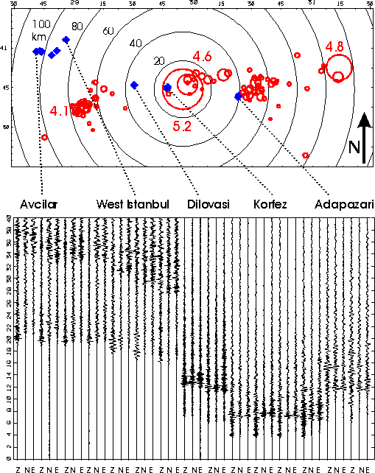
Figure 1: A) Map of Kocaeli Earthquake aftershock zone. The black concentric circles centered on the mainshock epicenter are in 20-km increments. The red circles are aftershock locations (from Seismological Observatory, KOERI: <http://www.koeri.boun.edu.tr/geophy/anasayfa/eanafr.html> | Seismology | Recent Earthquakes Text) and their radii are proportional to Brune-source radii, the magnitudes of the four largest events are annotated. The blue diamonds are the locations of individual seismographs and/or small-aperture seismic arrays, and they are connected by dotted lines to the town names of the recording sites. B) The corresponding three-components (Z, N, E) of ground motion recorded at these sites are shown as a pseudo-recordsection of 40-s duration. The amplitudes of each trace are normalized to the peak value of that trace, i.e., amplitudes cannot be compared. Strong-motion records are plotted as acceleration in the eastern epicentral region, weak-motion records are plotted as velocity in Avcilar and West Istanbul.

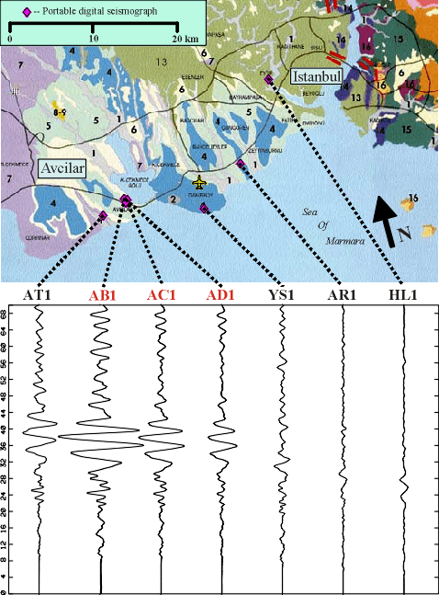
Figure 2: A) Geotechnical surficial geology map of Avcilar and West Istanbul (Municipality of Istanbul): [1-3] alluvium with low-loading capacities where load capacity increases from 1 to 3; [4] alluvium with good loading capacity with weak zones locally; [5] alluvium with low-loading capacity with increase probability of landslides on slopes reaching 14-15 degrees; [6] alluvium with high-loading capacity but landslides may occur where ground water accumulates at bottom of slopes; [7] alluvium with low-loading capacities with known damage to structures; [13] rock with high-loading capacities except on slopes. B) The radial components that have been low-pass filtered at 0.25 Hz (4.0 s) exhibit Rayleigh waves that are significantly amplified at sites in the damaged area of Avcilar.
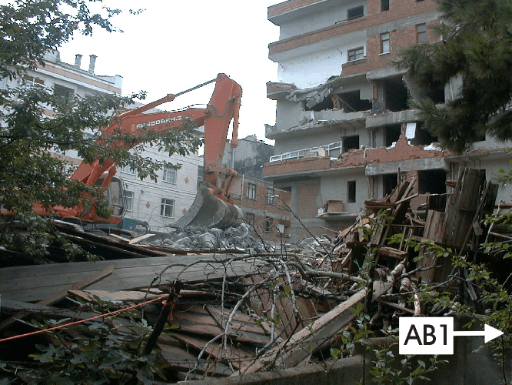
Figure 3: Collapsed 6-story apartment building adjacent to Station AB1 of the small-aperture seismic array in the damaged area of Avcilar.
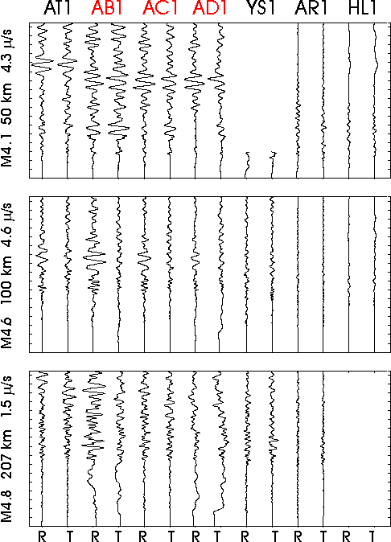
Figure 4: Radial (R) and tangential (T) ground-velocity components of three of the larger aftershocks; see annotated events in Figure 1A. All records have been low-pass filtered at 0.25 Hz and plotted at the same time scale with a 70-s duration. The records of each event are plotted at the same amplitude scale and the peak amplitude is annotated with the magnitude and epicentral distance on the left.
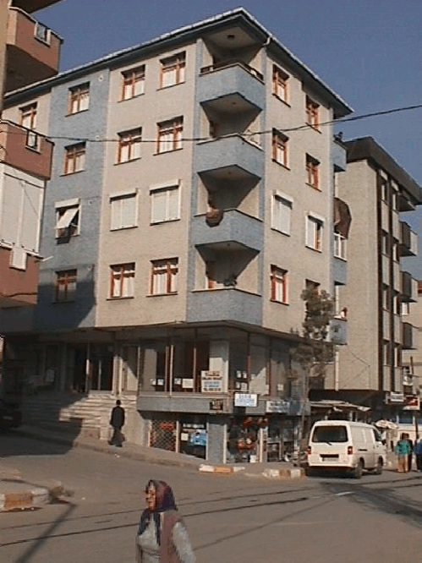
Figure 5: Building in the damaged area of Avcilar that we tested in this study. Note that the building has six stories in the front and less than that on the side with the stairs. This building is approximately 100 m south of the building that collapsed adjacent to Station AB1.

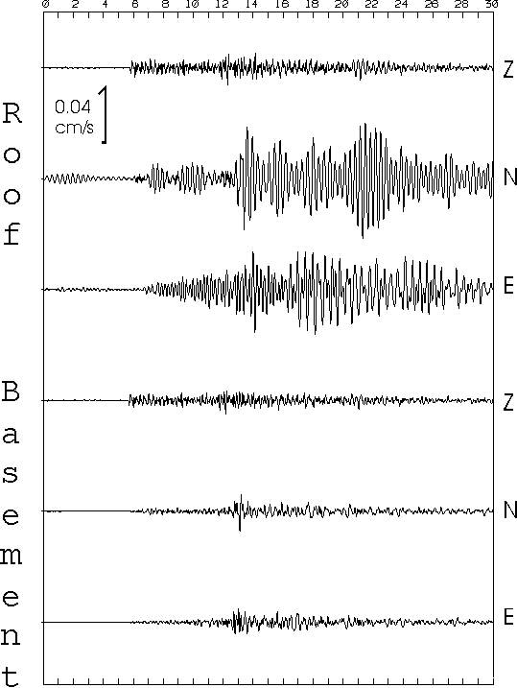

Figure 6: Response of 6-story apartment building to a M3.9 aftershock at a distance of ~40 km. All traces are plotted on the same amplitude and time scales.

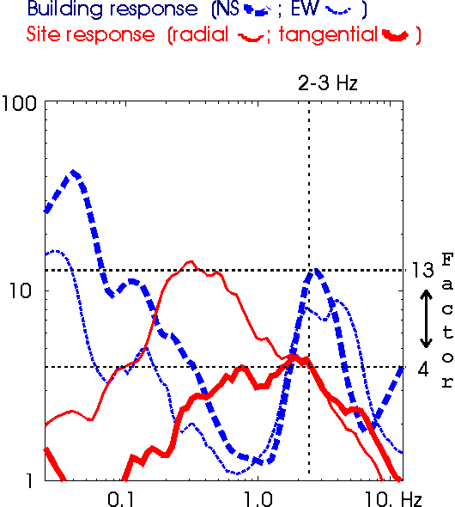
Figure 7. Spectral ratios that have been smoothed over octave-wide intervals and plotted on the same amplitude and frequency axes.

